1.Create a blog or website using Blogspot and wordpress . customize the theme design and post new article with 500 words

Coffee shop

Design shot:

Blogspot link: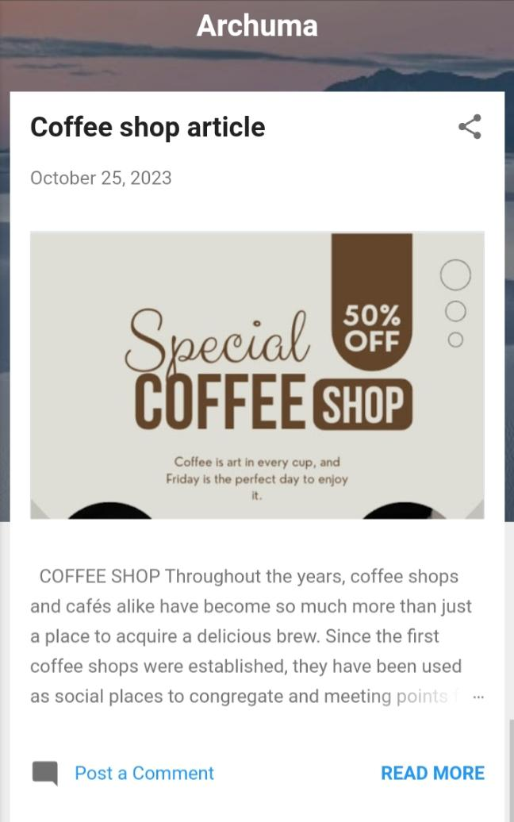https://archuma1997.blogspot.com/?m=1